**23CSE111**

**OBJECT ORIENTED PROGRAMMING**

**LAB MANUAL**



**Department of computer and communication Engineering**

**Amrita School of Engineering**

**Amrita Vishwa Vidyapeetham, Amaravati Campus**

**Name:M.Priya darshini**

**Verified By Roll No: AV.SC.U4CSE24221**

|  |  |  |  |  |
| --- | --- | --- | --- | --- |
| SNo | Title | Date | Page No | Signature |
| WEEK 1 |  |  |  |  |
| 1. | Download and Install Java Software | 07 |  |  |
| 2. | Write a Java program to print the message “Welcome to Java Programming.” | 11 |  |  |
| WEEK 2 |  |  |  |  |
| 1. | Write a Java program to calculate area of rectangle. | 13 |  |  |
| 2. | Write a java program to calculate the area of the triangle. | 14 |  |  |
| 3. | Write a Java program to convert temperature from Fahrenheit to Celsius | 15 |  |  |
| 4. | Write a Java program to convert temperature from Celsius to Fahrenheit. | 16 |  |  |
| 5. | Write a Java program to calculate factorial of a number. | 17 |  |  |
| 6. | Write a Java program to calculate fibonacci of a number. |  |  |  |
| 7. | Write a Java program to calculate Simple interest. |  |  |  |
| WEEK 3 |  |  |  |  |
| 1. | Write a java program with  1. A class with name Car.  2.Create 4 attributes named car_color , car_brand ,fuel_type ,mileage. 3.Create 3 methods named start() ,stop() ,service(). 4.Create 3 objects named car1, car2 ,car3. | 19 |  |  |
| 2. | Write a java program with 1.Create a class named Bankaccount. 2. Create a constructor. 3. Create 2 methods which are withdrawl() and deposit (). | 21 |  |  |
| WEEK 4 |  |  |  |  |
| 1. | Write a java program with class named book. This class should contain various attributes such as title, author ,year of publication. It should also contain a constructor with parameters which initializers title ,author ,year of publication. Create a method which displays the details of the book .Display the details of 2 books. | 25 |  |  |
| 2. | Create a java program with class named myclass with a static variable count of int type ,initial value to zero and a constant variable "pi" of type double initialize to 3.14 as attributes of that class ,now define a constructor for "myclass" that increments the count variable each time an object of myclass is created. Finally print the values of count and pi variables . Create 3 objects. | 27 |  |  |
| WEEK 5 |  |  |  |  |
| 1. | Create a calculator using the operations including addition, subtraction, multiplication, and division using multi-level inheritance and display the desired output. | 30 |  |  |
| 2. | A vehicle rental company wants to develop a system that maintains information about different types of vechicles available for rent the company rents out cars and bikes, and they need a program to store details about each vehicle, such as brand and speed( should be in super class)  1.cars should have an additional property: no.of doors 2.Bikes should have a property indicating whether they have gears or not. 3.The system should also include a function to display details about each vehicle and indicate when a vehicle is starting. 4.Every class should have a constructor. **Question:**  1.Which oops concept is used in the above program  2.If the company decides to add a new type of vehicle, Truck, how would you modify the program?  a.Truck should include an additional property capacity (in tons)  b.Create a showTruckdetails() method to display the truck’s capacity.  c.Write a constructor for Truck that initializes all properties Implement the truck class and update the main method to create a Truck object and also create an object for car and bike sub classes Finally, display the details. | 33 |  |  |
| WEEK 6 |  |  |  |  |
| 1. | Write a java program to create a vehicle class with a method displayinfo(). Override this method in the car subclass to provide specific information about a car. | 39 |  |  |
| 2. | A college is developing an automated admissions systems that verifies students eligibility for undergraduate(UG) and postgraduate(PG) programs. Each program has different eligibility. Criteria based on the students percentage in their previous qualification.  1. UG admission require min of 60%  2. PG admission require min of 70% | 41 |  |  |
| 3. | Create a calculator class with overloaded methods to perform addition.  A. Add two integers  B. Add two double  C. Add three integer | 43 |  |  |
| 4. | Create a shape class with a method CalculateArea() that is overloaded for different shapes (e.g square, rectangle) then, create a subclass circle that overrides the calculatearea() method for a circle. | 45 |  |  |
| Week-7 |  |  |  |  |
| 1. | Write the java program to create an abstract class Animal with an abstract method called sound().create Subclasses lion and tiger that the extend the animal class and implement the sound() method to make a specific sound for each animal. |  |  |  |
| 2. | Write the java program to create an abstract class shape3D with the abstract methods calculatevolume()  And calculatesurface Area().create subclasses sphere and cube that extends the shape3D class and implements the respective methods to calculate the volume and surface area of each Shape. |  |  |  |

**WEEK 01**

**PROGRAM-1:**

**AIM:** Download and Install Java Software

**PROCEDURE:**

**Step 1: Download JDK 21**

1.Open chorme wed brower and go to the Oracle JDK download page.

2.Go to down Java SE Development Kit 21 section.

3. Choose the Windows x64 Installer version.

4.Click on Download, then Wait for the download to complete.

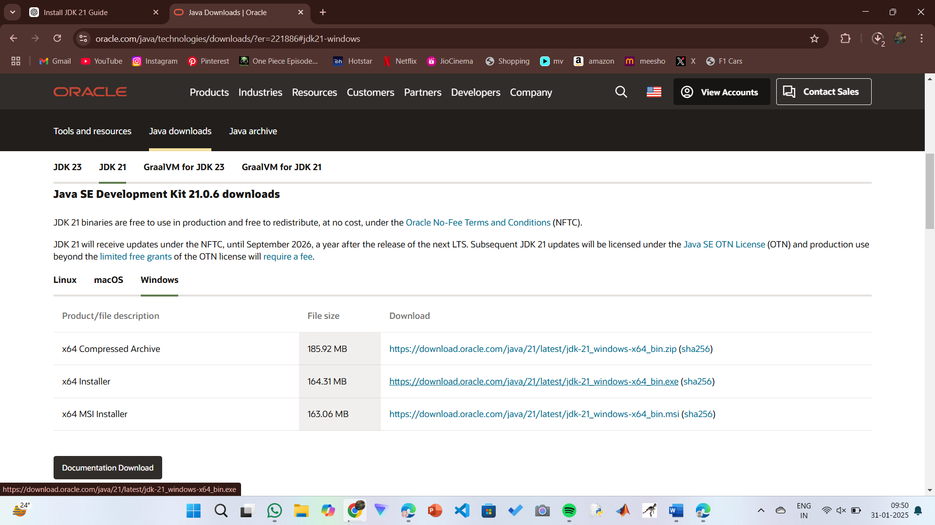

**Step 2:** **Install JDK 21**

1.Run the downloaded installer jdk-21_windows-x64_bin.exe file.

2. Double-click to launch the installer.

3.click “next” to start the installation process.

4.Accept the license agreement and click next.

5. Choose the installation path (default is C:\Program Files\Java\jdk-21).

6.Wait for the installation to complete.

7.Click Close to the installation is finished.

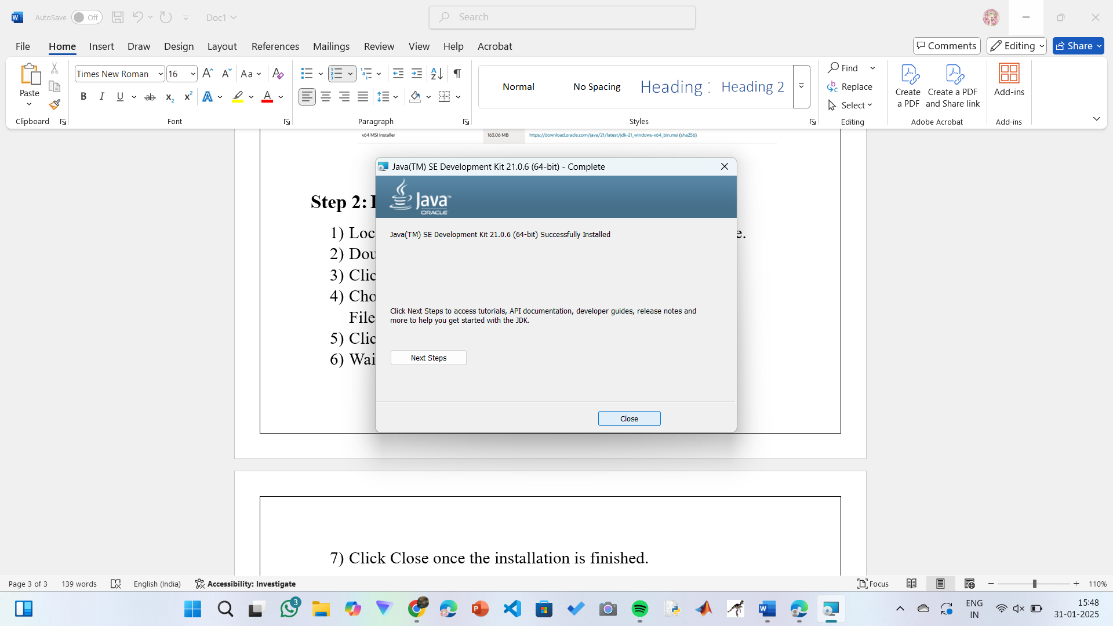

**Step 3: Setting up the path**

1.Go to “Windows C” Drive on Desktop.

2. Choose Program Files, select Java, then JDK 21, then select Bin.

3. Select and copy the path at the address bar.

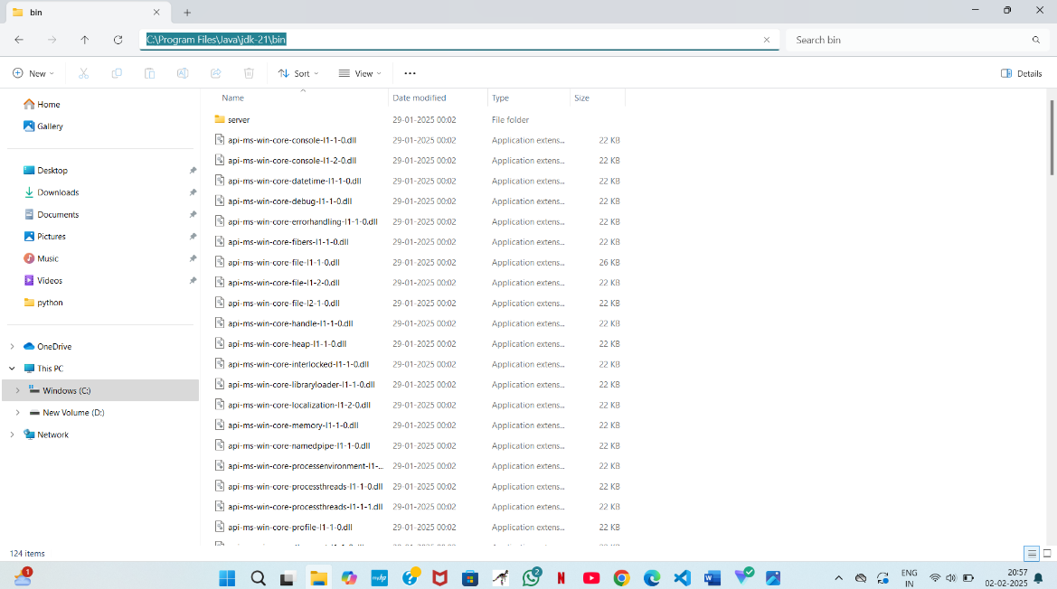

**Step 4: Open System Properties**

1.Press Windows + R, type sysdm.cpl , and click Ok-

2.The System Properties window will open.

3.Navigate to the Advanced tab.

4.Click on Environment Variables at the bottom.

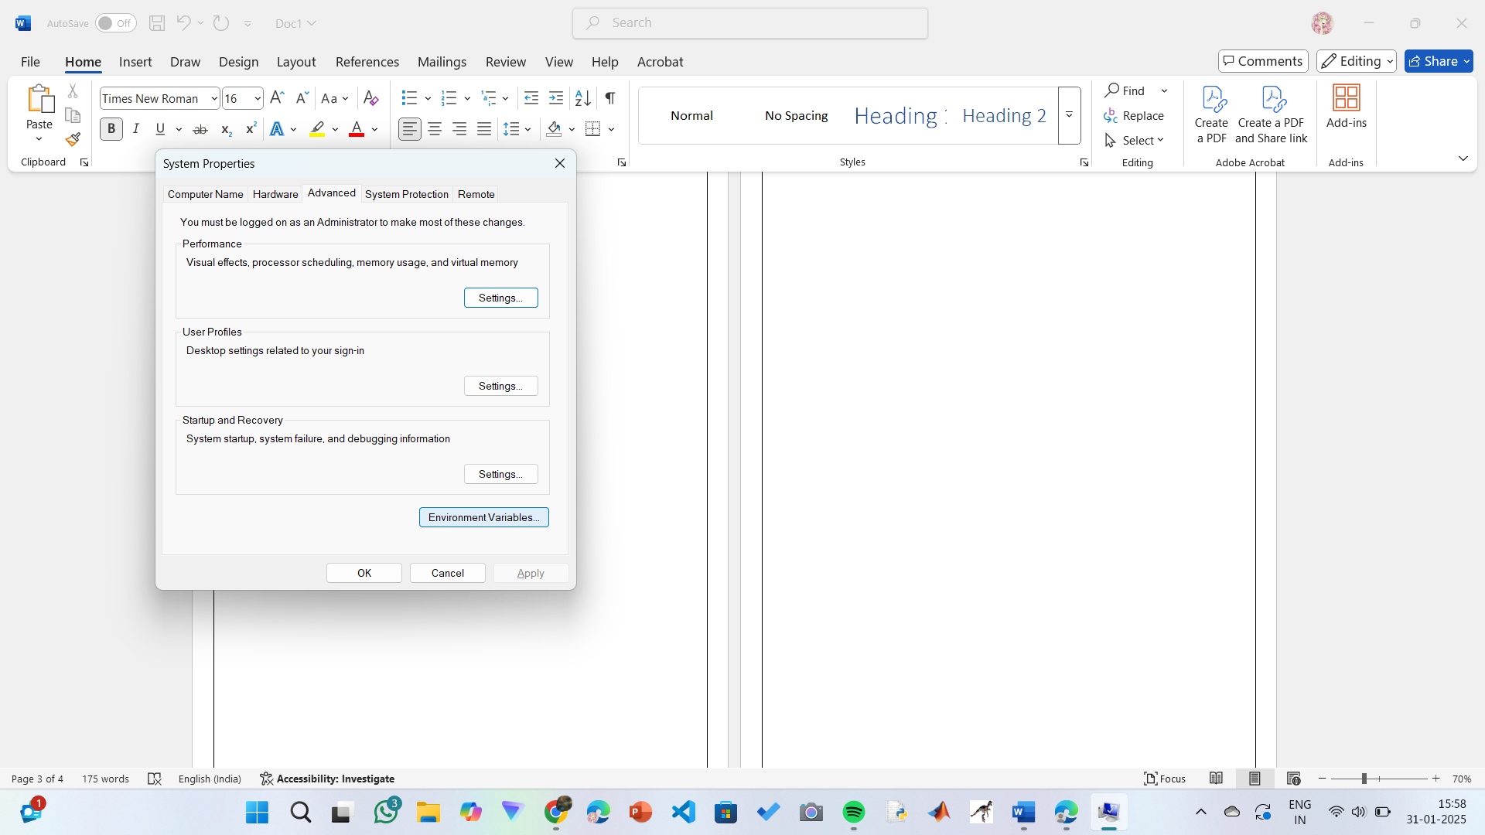

**Step 5: Set JAVA_HOME**

1.Under System Variables, click New.

2.Set the Variable name as JAVA_HOME.

3.Set Variable value as C:\Program Files\Java\jdk-21 (or your installation path).

4.Click OK.

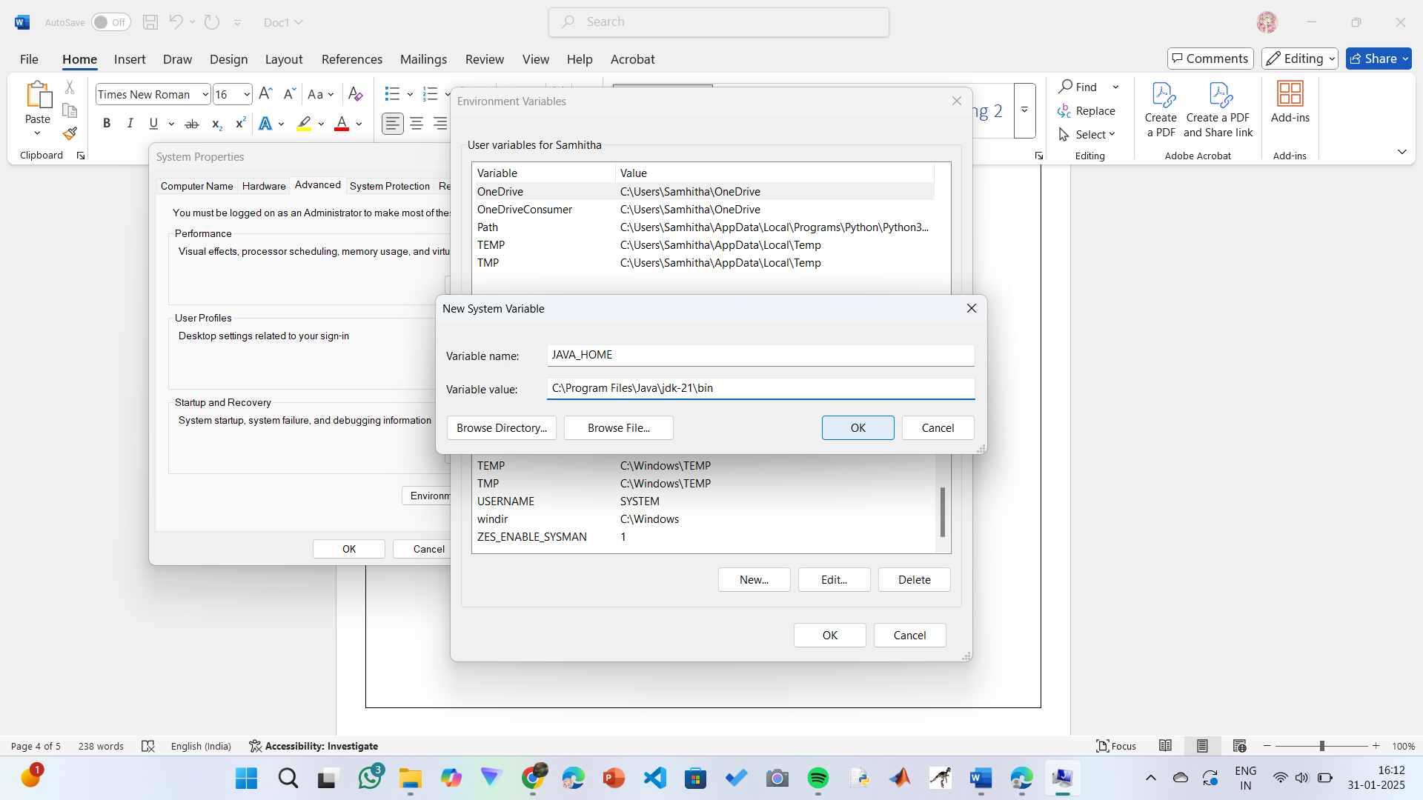

**Step 6: Update PATH Variable**

1.In System Variables, find Path and click Edit.

2.Click New and add: C:\Program Files\Java\jdk-21\bin

3.Click OK to save.

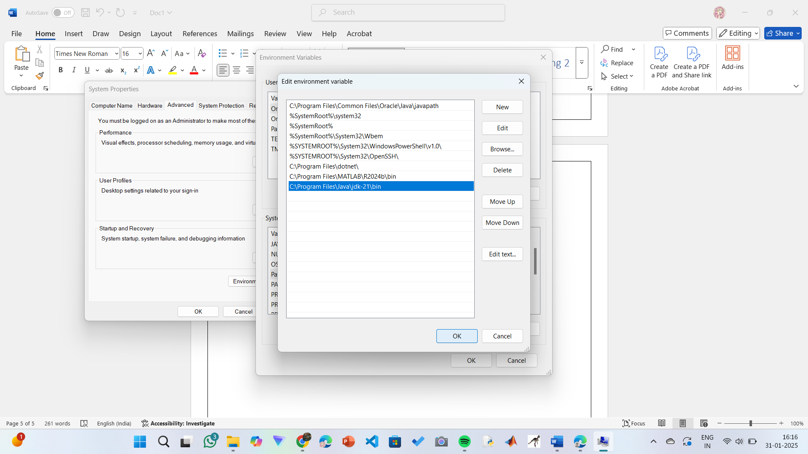

**Step 7:Verify Installation**

1.Open a command prompt or terminal window.

2. Type java -version: Type java -version to verify that Java is installed correctly.

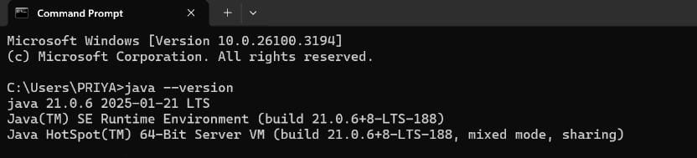

3. To check the java compiler type: javac –version.

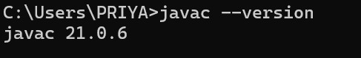

**PROGRAM-2:**

**AIM:** Write a Java program to print the message “Welcome to Java Programming.”

**CODE:**

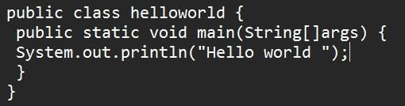

**Output:**

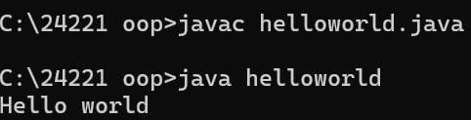

**ERRORS:** None found

**PROGRAM-3:**

**AIM:** Write a Java Program that prints Name, Roll No, Section of a student.

**CODE:**

**STUDENT DETAILS:**

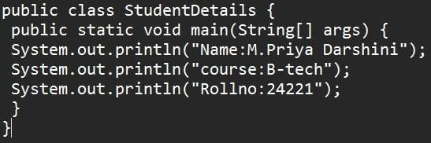

**OUTPUT:**

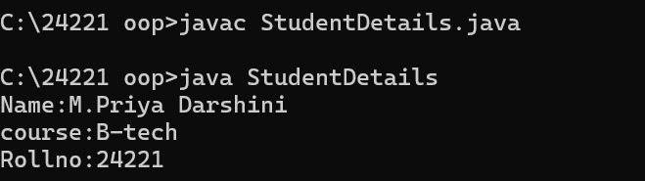

**ERROR TABLE:**

|  |  |
| --- | --- |
| Code Error | Code rectification |
| 1.writing small “S” in place of” S”  In (string [] | 1.code is rectified by keeping capital “S” |

**WEEK – 2**

**PROGRAM-1:**

**AIM:** Write a java program to find the simple interest where all the inputs are taken from the user.

**CODE:**

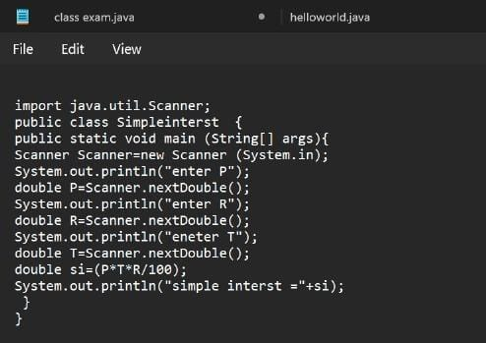

OUTPUT:

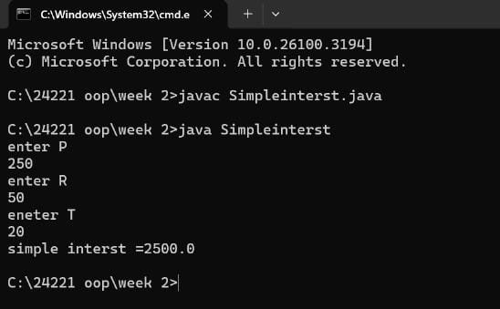

**ERROR TABLE:**

|  |  |  |
| --- | --- | --- |
|  | ERROR | ERROR RECTIFICATION |
| 1) | ; is expected after input.close() | Corrected by writing a ; after input.close() |
| 2) | Error in the line double principal=input.next.double(); | Corrected by removing “. “after the next. |

**PROGRAM-2:**

**AIM:** Write a java program to find the factorial of a number where all the inputs are taken from a user.

**CODE:**

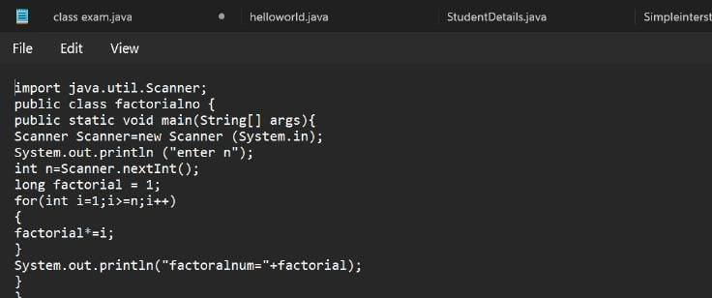

**OUTPUT:**

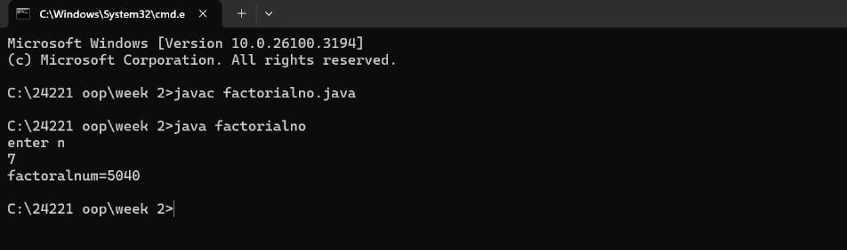

**ERROR TABLE:**

|  |  |  |
| --- | --- | --- |
|  | **ERROR** | **ERROR RECTIFICATION** |
| 1) | writing small “S” in place of “S” in system .out. println () | code is rectified by keeping capital “S” |
| 2) | “Is missed in the print statement | Corrected by keeping “in the end of print statement. |

**PROGRAM-3:**

**AIM:** Write a java program to convert the temperature from Celsius to Fahrenheit and Celsius to Fahrenheit.

**CODE:**

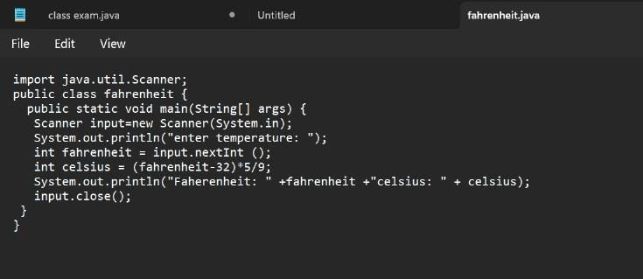

**OUTPUT:**

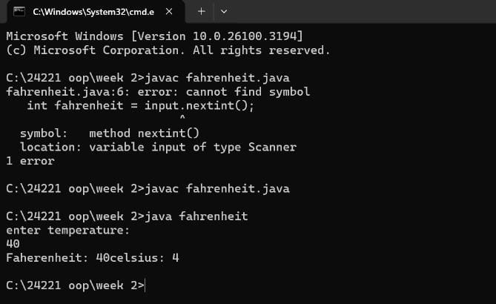

**ERROR TABLE:**

|  |  |  |
| --- | --- | --- |
| **S.NO** | **ERROR** | **ERROR RECTIFICATION** |
| 1. | Logical error  Missed * after Celsius in code 1 | Corrected by keeping a * operator in the appropriate place |

**PROGRAM – 4:**

**AIM:** Write a java program to find the Fibonacci series of a given number where all the inputs are taken from the user.

**CODE:**

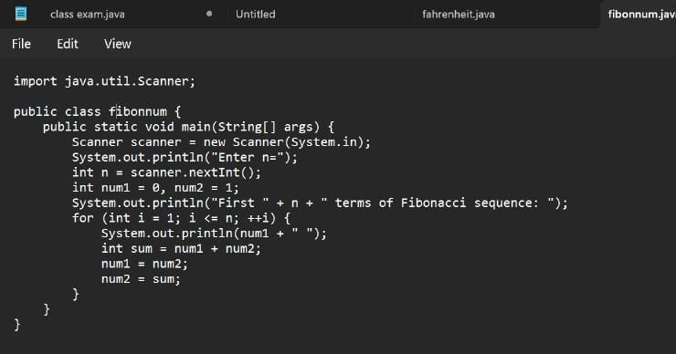

**OUTPUT:**

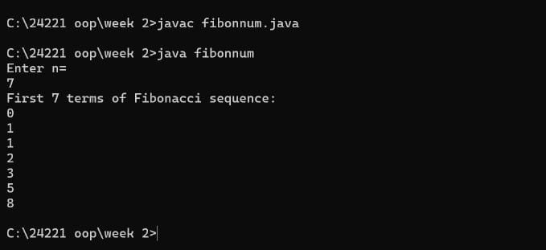

ERROR TABLE:

|  |  |  |
| --- | --- | --- |
| S.NO | ERROR | ERROR RECTIFICATION |
| 1. | Expected an; after line 4 | Corrected by keeping an ; after the line |

**PROGRAM-5:**

**AIM:** Write a java program to find the area of rectangle and triangle.

**CODE:** 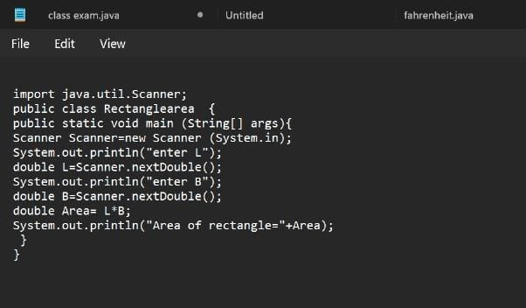

**OUTPUT:**

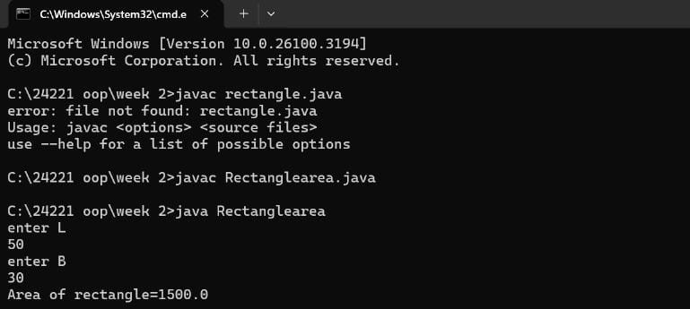

**ERROR TABLE:**

|  |  |
| --- | --- |
| Code Error | Code rectification |
| 1.Class name is rectangle area and error is small”r”. | 1.code is rectified keeping of capital”R”. |

**WEEK –3**

**PROGRAM-1:**

**AIM:** Write a java program with

1.Create a class named Bankaccount.

2. Create a constructor.

3. Create 2 methods which are withdrawl() and deposit ()

|  |
| --- |
| Bank account |
| -balance:double |
| +bank account initial  Balance:double  +deposit amount:double  +withdrawal:double  +getbalance():double |

**CODE:**

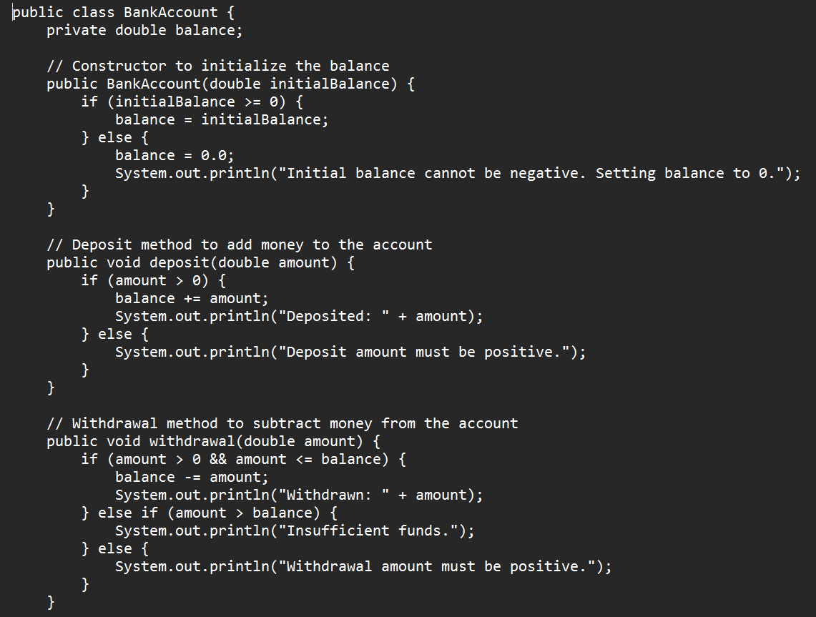

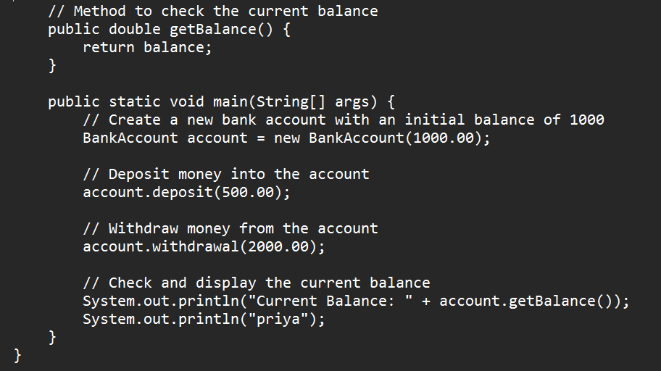

**OUTPUT:**

**POSITIVE CASE:** 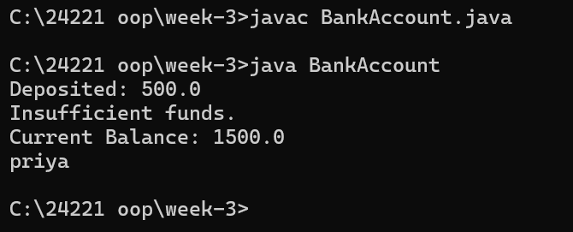

**NEGATIVE CASE:**

**ERROR TABLE:**

|  |  |  |
| --- | --- | --- |
| S.No | Errors | Rectification |
| 1 | Calling Non-Existent Methods  Ex: By typing titel instead of title while calling the method | Rectifying the method name as title |
| 2 | Semicolon after System.out.println is not given | The error is rectified by keeping the semicolon |

**IMPORTANT POINTS:**

Encapsulation:

* Using private fields and public methods to protect the data and control access.

Conditionals:

* Using if statements to enforce rules and conditions

**Program-2**

**AIM:**To create java program with following instructions

1. Create a class with name Car.
2. Create four attributes named Car_color, Car_brand, fuel_type, mileage.
3. Create three methods named start (), stop (), service ().

4)Create three objects named Car1, Car2, Car3**.**

**CLASS DIAGRAM:**

|  |
| --- |
| Car |
| + Car_color: String  + Car_brand: String  - fuel_type: String  - mileage: double |
| + start(): void  + stop(): void  - service(): void  + Car1(): void  + Car2(): void  + Car3(): void |

**CODE:**

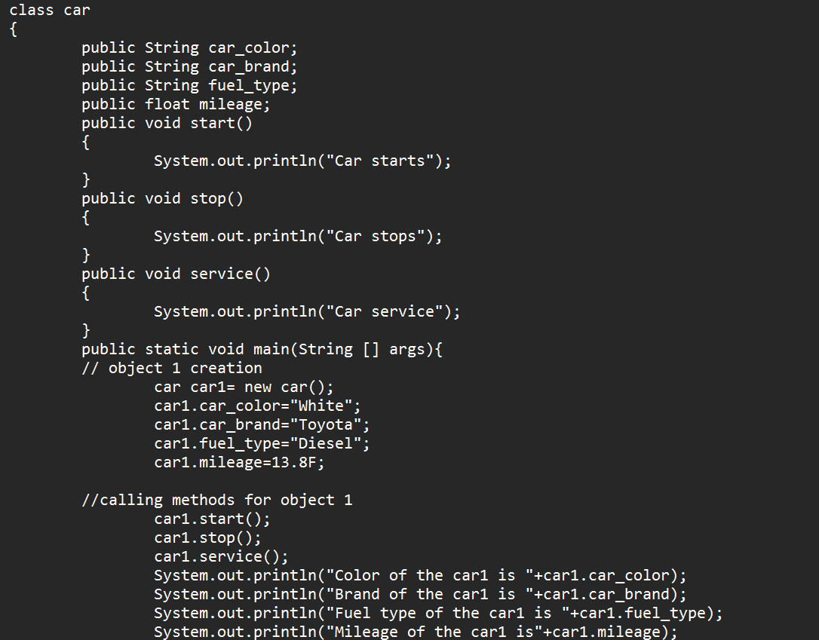

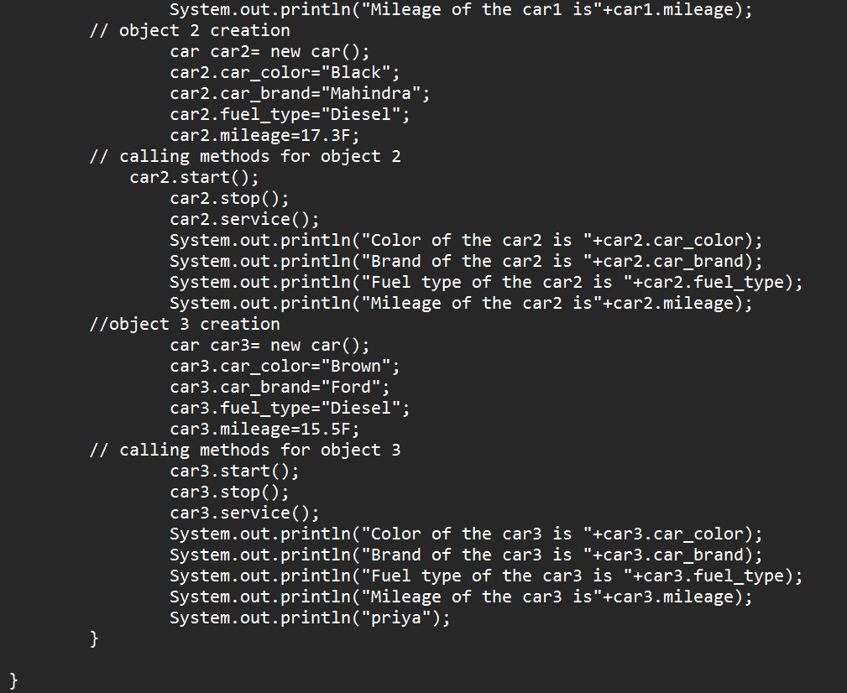

**OUTPUT:**

**POSITIVE CASE:**

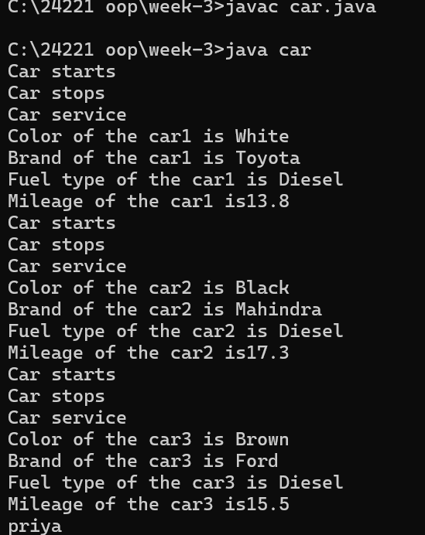

**NEGATIVE CASE:**

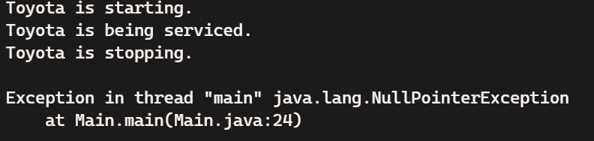

**ERROR TABLE:**

|  |  |  |
| --- | --- | --- |
| S.No | Errors | Rectification |
| 1 | Calling Null Methods which are not define | Rectifying the correct method names |
| 2 | Semicolon after System.out.println is not given | The error is rectified by keeping the semicolon |

**Important Points:**

1. Classes and Objects:
   * Class: A blueprint for creating objects (a particular data structure), containing methods and variables.
   * Object: An instance of a class.
2. Attributes:
   * Variables within a class that represent the state or properties of an object.
3. Constructor:
   * A special method used to initialize objects. It is called when an object of a class is created.
4. Methods:
   * Functions defined within a class that represent the behavior or actions that an object can perform**.**

**WEEK-4**

**PROGRAM-1**

**Aim:** Write a java program with class named book. The class should contain various attributes such as title, author, year of publication. It should also contain a constructor with parameters which initializes title, author and year of publication. Create a method which displays the details of the book. Display the details of two books.

|  |
| --- |
| Book |
| - title: String  - author: String  - year_of_publication: int |
| + Book(String, String, int)  + title(): void  + author(): void  + year(): void  + main(String[]): static void |

**CODE:**

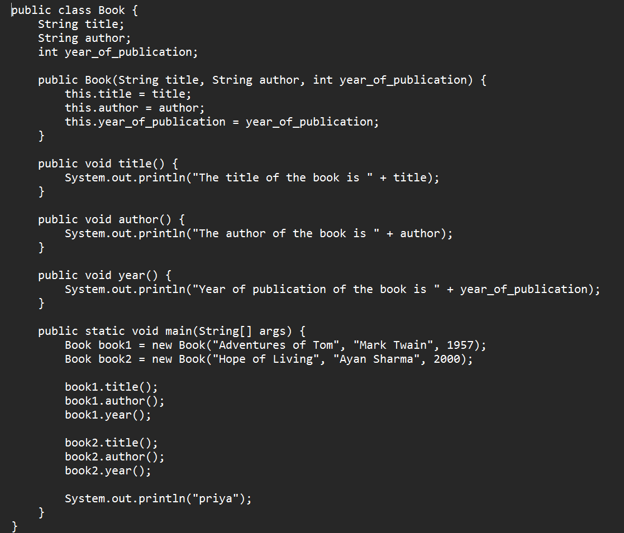

**OUTPUT**

**POSITIVE CASE:**

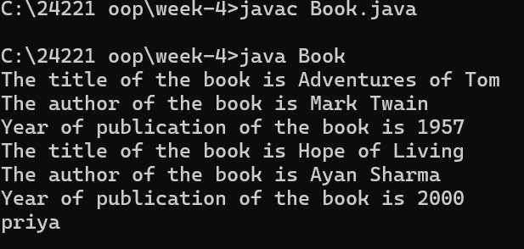

**NEGATIVE CASE:**

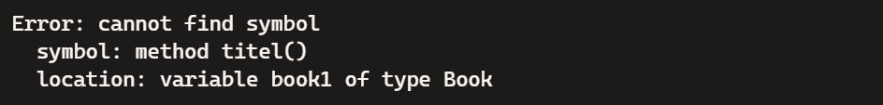

**ERROR TABLE:**

|  |  |  |
| --- | --- | --- |
| S.No | Errors | Rectification |
| 1 | Calling Non-Existent Methods  Ex: By typing titel instead of title while calling the method | Rectifying the method name as title |
| 2 | Semicolon after System.out.println is not given | The error is rectified by keeping the semicolon |

**IMPORTANT POINTS:**

Using a constructor to initialize object attributes when a new object is created. Defining methods (title(), author(), year()) to perform specific tasks within the class.Using the main method as the entry point to the program.

**PROGRAM-2:**

**AIM:** Create a java program with class named “MyClass” with a static variable count of int type initialized to zero and a constant variable ‘pi’ of type double initialized to 3.14 as attributes of that class. Now define a constructor for “MyClass” that increments the count variable each time an object of “MyClass” is created. Finally print the final values of count and pi variables. Create three variables.

**CLASS DIAGRAM:**

|  |
| --- |
| MyClass |
| - count: static int  - pi: final double |
| + MyClass ()  + main (String []): static void |

**CODE:**

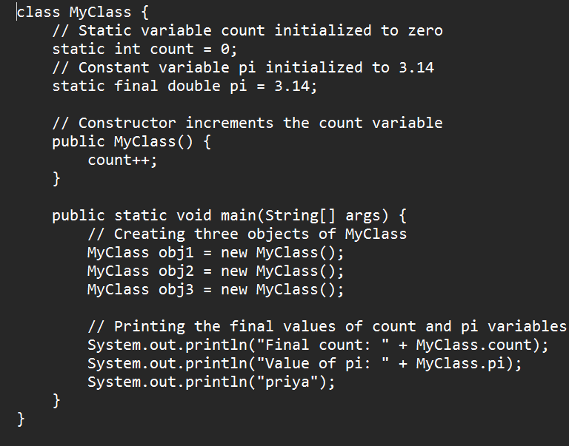

**OUTPUT:**

**POSITIVE CASE:**

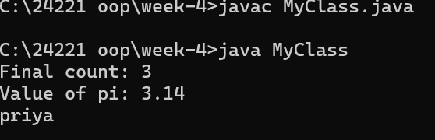

**NEGATIVE CASE:**



**ERROR TABLE:**

|  |  |  |
| --- | --- | --- |
| S.No | Errors | Rectification |
| 1 | Calling Non-Existent Methods  Ex: By typing Myclass instead of MyClass while calling the method | Rectifying the method name as MyClass |
| 2 | S is System.out.println is given in lowercase letters | The error is rectified by replacing the lowercase letter s into uppercase letter S |

**Important Points:**

1. **Static Variables**:
   * count: A static variable shared among all instances of the class. It keeps track of the number of objects created.
   * pi: A static constant variable, its value remains the same for all instances.
2. **Constructor**:
   * Increments the count variable each time an object is created.
3. **Static Context**:
   * Accessing static variables and methods using the class name (MyClass.count, MyClass.pi)

**WEEK-5**

**PROGRAM-1**

**AIM:** Create a calculator using the operations including addition, subtraction, multiplication and division using Multilevel Inheritance and display the desired output.

**CLASS DIAGRAM:**

**MULTILEVEL INHERITANNCE**

|  |
| --- |
| Calculator |
| - num1: int  - num2: int |
| + add(): int  + subtract(): int |

|  |
| --- |
| Calculator1 |
| - num1: int  - num2: int |
| + multiply(): int |

|  |
| --- |
| Calculator2 |
| - num1: int  - num2: int |
| + divide(): int |

**CODE:**

class Calculator {

    public int add(int a, int b) {

        return a + b;

    }

    public int subtract(int a, int b) {

        return a - b;

    }

}

class Calculator1 extends Calculator {

    public int multiply(int a, int b) {

        return a * b;

    }

}

class Calculator2 extends Calculator1 {

    public double divide(int a, int b) {

        return (double) a / b; // Fixed: Ensure division returns a double

    }

}

public class CalculatorTest {

    public static void main(String[] args) {

        Calculator2 calc = new Calculator2();

        int num1 = 10, num2 = 5;

        System.out.println("num1 = " + num1);

        System.out.println("num2 = " + num2);

        System.out.println("Addition: " + calc.add(num1, num2));

        System.out.println("Subtraction: " + calc.subtract(num1, num2));

        System.out.println("Multiplication: " + calc.multiply(num1, num2));

        System.out.println("Division: " + calc.divide(num1, num2));

        System.out.println("priya");

    }

}

**Output:**

**POSITIVE CASE:**

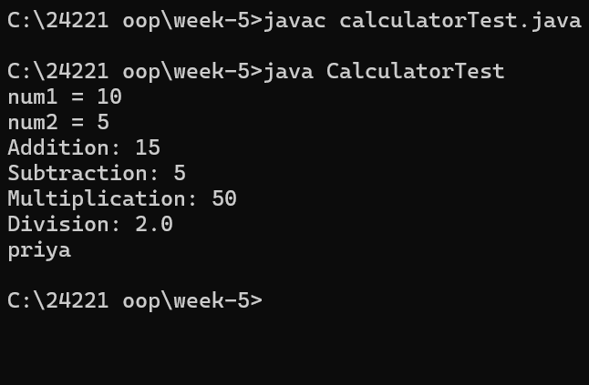

**NEGATIVE CASE:**

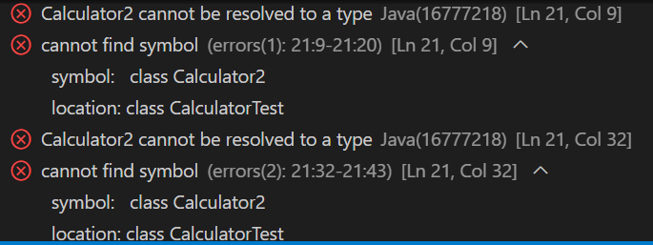

**ERROR TABLE:**

|  |  |  |
| --- | --- | --- |
| S.No | Errors | Rectification |
| 1 | Given wrong class name while object is created | Rectifying the given wrong class name |

**IMPORTANT POINTS**

1. Multilevel Inheritance:

* Multilevel inheritance occurs when a class is derived from another class, and then a third class is derived from the second class, forming a chain.

2. Code Reusability:

* The add() and subtract() methods are defined once in the Calculator class and can be reused by both the Calculator1 and Calculator2 classes without rewriting the code.
* The multiply() method is defined in Calculator1 and inherited by Calculator2
* The divide() method is added to the Calculator2 class.
* This shows how inheritance helps to reduce redundant code and increases reusability.

3. Polymorphism (Use of Parent Class Reference):

* The code demonstrates polymorphism (though not explicitly in the form of method overriding). Even though the object calc is of the class Calculator2, it can call methods from the base class (Calculator) and intermediate class (Calculator1) due to inheritance.

For example, calling calc.add(num1, num2) and calc.subtract(num1, num2) works because Calculator2 inherits from Calculator

**PROGRAM-2**

**AIM:** A vehicle rental company wants to develop a system that maintains information about different types of vehicles available for rent. The company rents out cars and bikes and they need a program to store details about each vehicle such as brand and speed

* Cars should have an additional property: number of doors
* Bike should have a property indicating whether they have gears or not
* The system should also include a function to display details about each vehicle and indicate when a vehicle is starting
* Every class should have a constructor

1. Which OOP concept is used in the above program? Explain why it is useful in this scenario.
2. If the company decides to add a new type of vehicle truck, how would you modify the program? Truck should include an additional property capacity(in tons). Create a showTruckDetails() method to display the truck’s capacity. Write a constructor for truck that initializes all properties.
3. Implement the truck class and update the main method to create a truck object, also create an object for car and bike subclassed. Finally display its details.

**CLASS DIAGRAM**:

|  |
| --- |
| Vehicle |
| + brand: String  + speed: int |
| + Vehicle(brand: String, speed: int)  + start(): void  + displayDetails(): void |

|  |
| --- |
| Car |
| +numberOfDoors: int |
| +Car(brand:String, speed: int, numberOfDoors: int)  + displayDetails(): void |

|  |
| --- |
| Bike |
| + hasGears: boolean |
| + Bike(brand: String, speed: int, hasGears: boolean) +displayDetails(): void |

|  |
| --- |
| Truck |
| + Capacity : double |
| +Truck(brand: String, speed: int, Capacity: double)  +showTruckDetails(): void |

**CODE:**

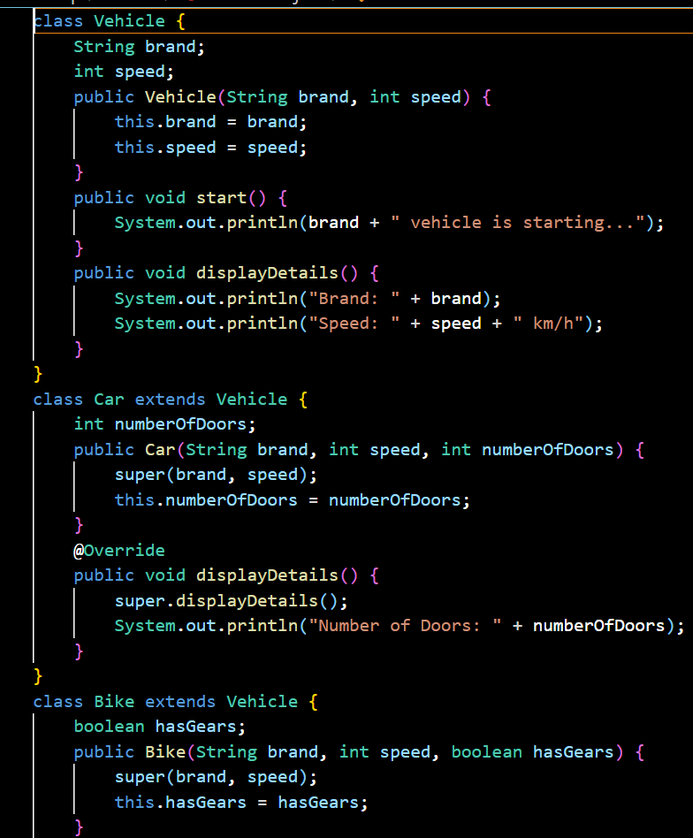

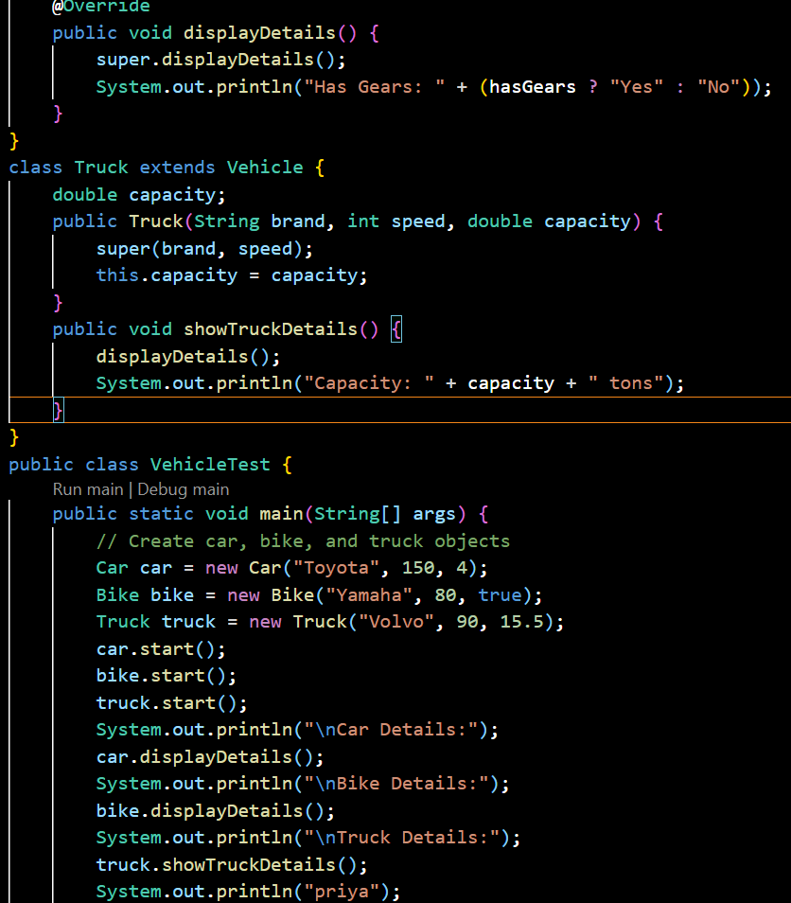

**OUTPUT:**

**POSITIVE CASE:**

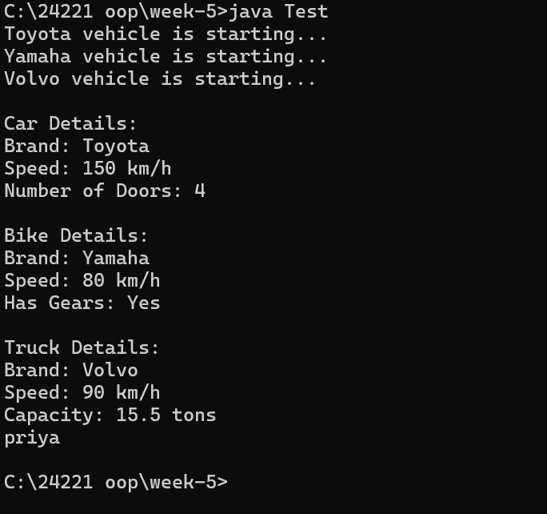

**NEGATIVE CASE:**

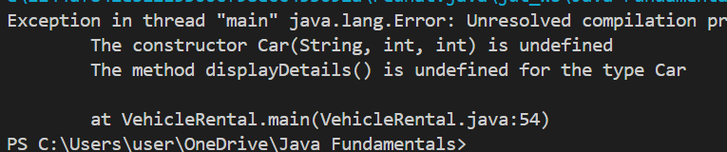**ERROR TABLE:**

|  |  |  |
| --- | --- | --- |
| S.No | Errors | Rectification |
| 1 | Given wrong class name while object is created | Rectifying the given wrong class name |

**IMPORTANT POINTS:**

1. Class Inheritance:

* Vehicle Class: The Vehicle class serves as the base class. It contains common properties (like brand and speed) and methods (start() and displayDetails()) that are shared by all vehicle types.
* Car, Bike, and Truck Classes: These are subclasses that extend the Vehicle class. They inherit the properties and methods of the Vehicle class but can add their own specific properties (like numberOfDoors for Car, hasGears for Bike, and capacity for Truck).

2. Constructor Inheritance:

* The Car, Bike, and Truck classes use the super() keyword to invoke the constructor of the Vehicle class, ensuring the shared properties (brand and speed) are initialized properly. Each subclass has its own specific constructor to initialize its additional properties.

3. Method Overriding:

* displayDetails() Method: Each subclass (Car, Bike, Truck) overrides the displayDetails() method from the Vehicle class to add more specific details about the subclass. The super.displayDetails() is used to first display the general vehicle information, then additional subclass-specific details are printed.

**WEEK-6**

**PROGRAM-1:**

**AIM:** Write a java program to create a Vehicle class with a method displayInfo(). Override this method in the Car subclass to provide specific information about a car.

**CODE:**

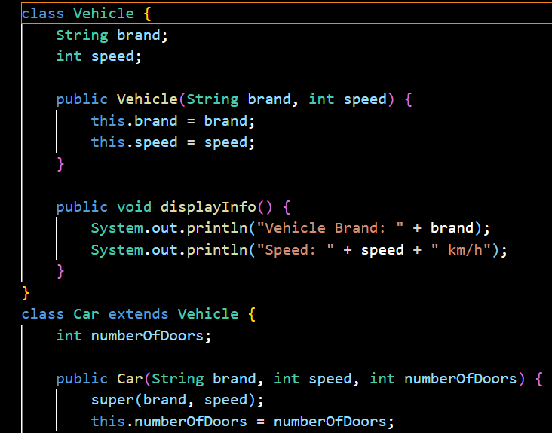

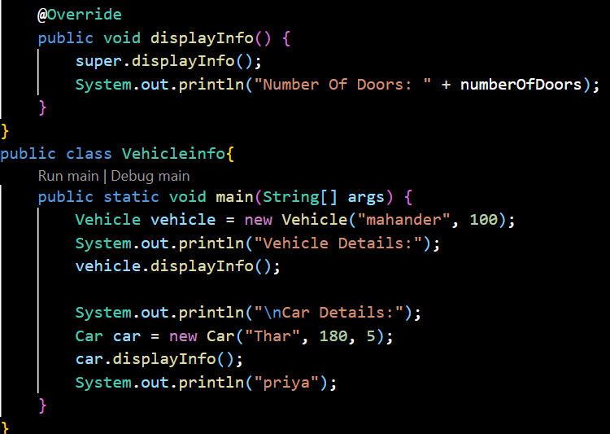

**OUTPUT:** 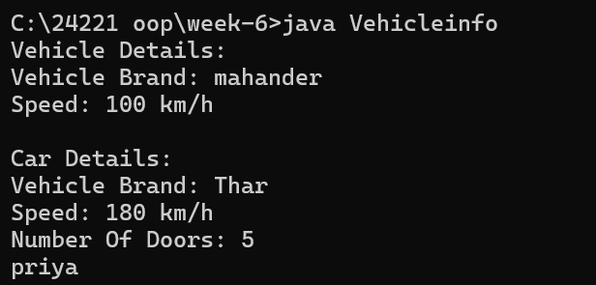

**ERROR TABLE:**

|  |  |  |
| --- | --- | --- |
| **S.NO** | **Error** | **Error rectification** |
| 1. | error: class Main is public, should be declared in a file named Main.java  public class Main { | Save the file name as the name of the main class |

**IMPORTANT POINTS:**

. We use the concept of method overriding where the names of the methods in the different classes. The method of the parent class is overridden by the method of the child class

**PROGRAM-2:**

AIM: A college is developing an automated admission system that verifies students’ eligibility for under-graduation and post-graduation. Each program has different eligibility criteria base on the percentage of students in their provided qualifications

* Ug requires 60%
* PG requires 70%

**CLASS DIAGRAM:**

|  |
| --- |
| **UG** |
| UG (String name, double percentage) |

|  |
| --- |
| **Student** |
| + name: String  + percentage: double |
| + Student (String name, double percentage): void  + Eligibility (): void |

|  |
| --- |
| **PG** |
| PG (String name, double percentage) |

**CODE:**

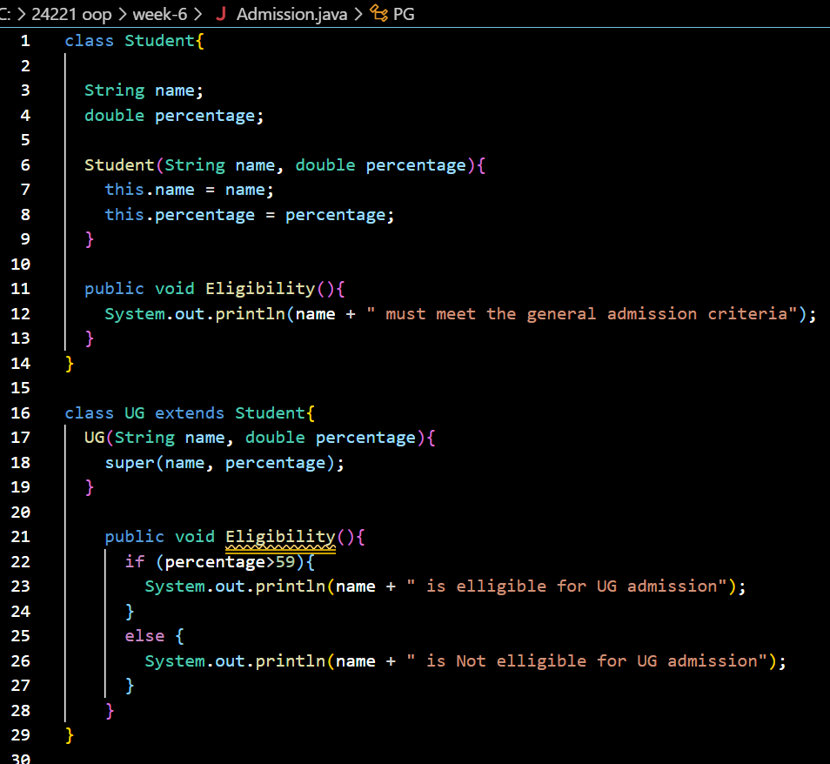

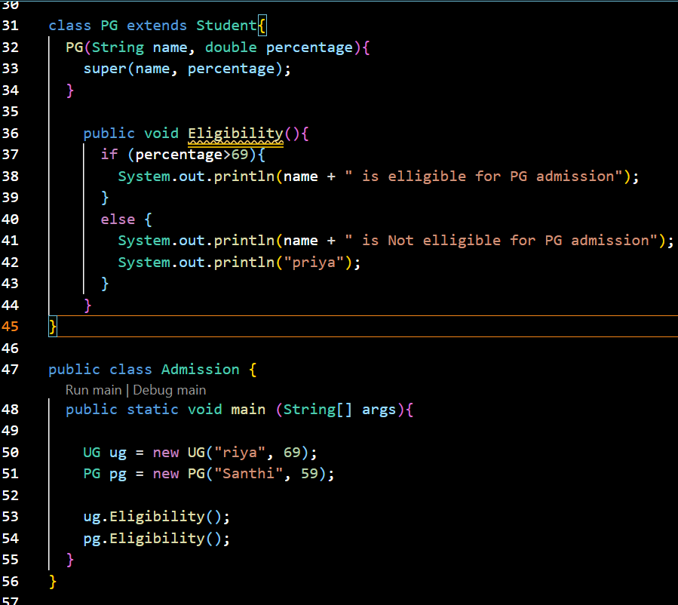

OUTPUT:

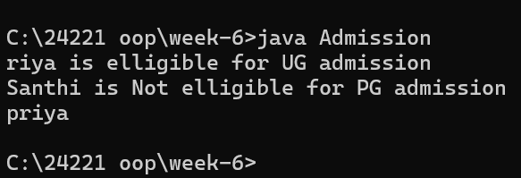

**ERRORS TABLE:**

|  |  |  |
| --- | --- | --- |
| **Sl. no** | **Error** | **Error rectification** |
| 1. | error: ';' expected System.out.println(name + " is elligible for UG a | Add a ‘;’ after the print statement. |

**PROGRAM-3:  
AIM:** Create a calculator with overloaded methods to perform addition:

i) Add two integers

ii) Add two doubles

iii) Add three integers

**CLASS DIAGRAM:**

|  |
| --- |
| **AddCalculator** |
| + AddCalculator ()  + add (int a, int b): int  + add (double a, double b): double  + add (int a, int b, int c): int |

**CODE:** 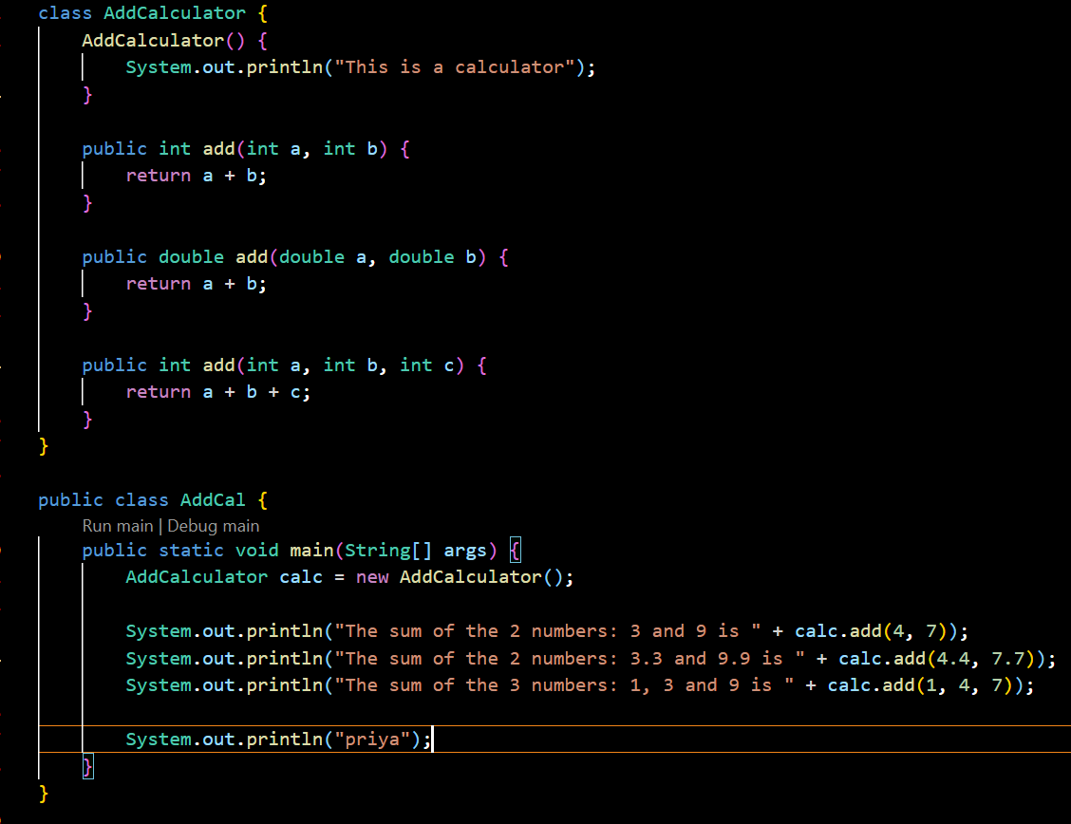

**OUTPUT:** 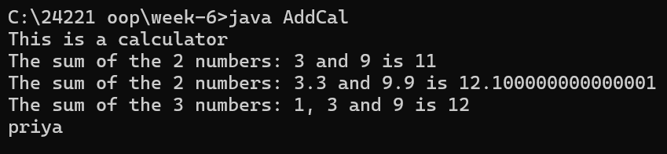

**ERROR TABLE:**

|  |  |  |
| --- | --- | --- |
| **S.NO** | **Error** | **Error rectification** |
| 1. | error: Main method not defined | Add public static void main (String [] args) { |
| 2. | error: ';' return type is not expected | Change return type from int to double in its case. |

**IMPORTANT POINTS:**

1. We use the concept of method overloading where the names of the methods in the same class are same but the parameters are given different.

**PROGRAM-4:**

**AIM:** Create a Shape class with a method calculateArea() that is overloaded for different shapes (e.g., square, rectangle).

Then create a subclass Circle that overrides the calculateArea() method for a circle.

**CLASS DIAGRAM:**

|  |
| --- |
| **Circle** |
| + r: double  + pi: double |
| + calcarea(int r): double |

|  |
| --- |
| **Shape** |
| + calcArea(int a): int  + calcArea(int b, int h): int |

**CODE:**

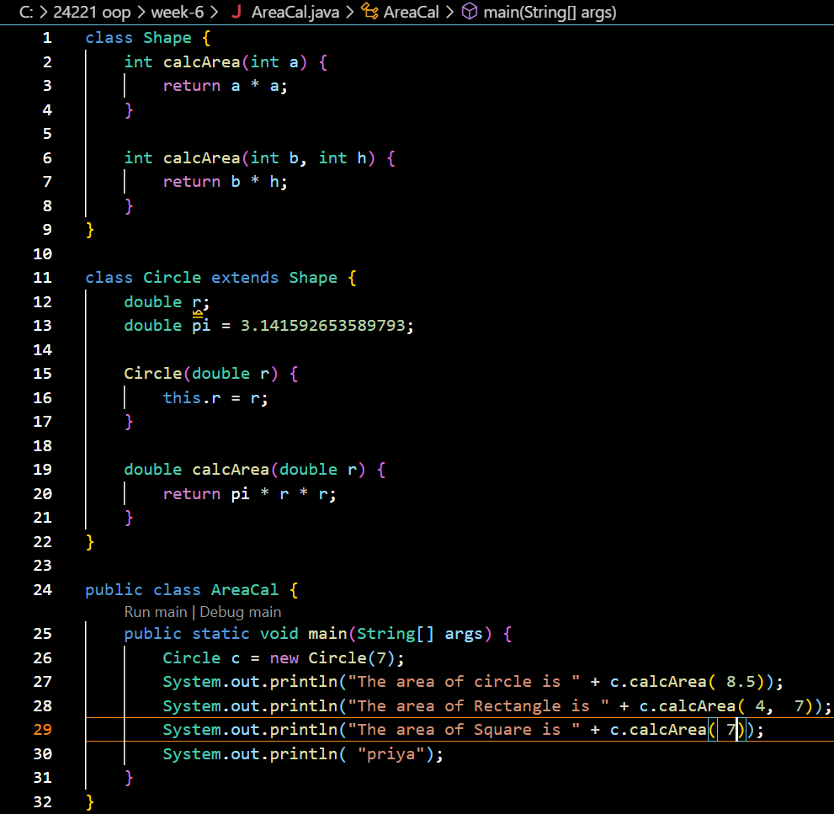

OUTPUT: 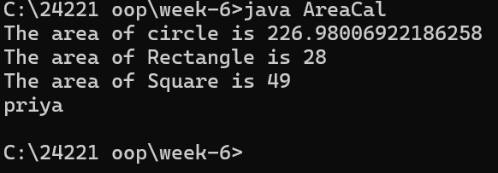

**ERROR TABLE:**

|  |  |  |
| --- | --- | --- |
| **S.NO** | **Error** | **Error rectification** |
| 1. | error: invalid method declaration; return type required  calcArea(int a) { | Enter the return type as per required. Here it is int |
| 2. | error: incompatible types: possible lossy conversion from double to int  return pi*r*r; | For calculating area of circle, we need to give return type double. |

**WEEK-7**

**PROGRAM-1:**

**AIM:** Write a Java program to create an abstract class Animal with an abstract method called sound (). Create subclasses Lion & Tiger that extend Animal class and implement the sound () method to make a specific sound for each animal.

**CLASS DIAGRAM:**

**CODE:**

abstract class animals {

    abstract void sound ();

}

class tiger extends animals {

    @Override

    public void sound () {

        System.out.println("tiger growls");

    }

}

class lion extends animals {

    @Override

    public void sound () {

        System.out.println("lion growls");

    }

}

public class Abstractani {

    public static void main (String [] args) {

        tiger tiger=new tiger ();

        tiger.sound();

        lion lion=new lion ();

        lion.sound();

        System.out.println("priya");

        System.out.println("24221");

    }

}

**OUTPUT:**

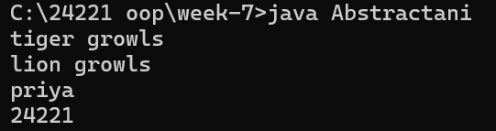

**ERROR TABLE:**

|  |  |  |
| --- | --- | --- |
| **S.NO** | **Error** | **Error rectification** |
| 1. | Implicity declared class not have main method in the form of void main () | Change the public class name based on the abstract class name. |
| 2. | In the given code; expected | Apply the; |
| 3. | Illegal the start of type |  |

**PROGRAM-2:**

**AIM:** Write a Java program using an abstract class to define a method for pattern printing.

Create an abstract class named PatternPrinter with an abstract method printPattern(int n).

Create concrete subclasses:

1. StarPattern - Prints a right-angled triangle of stars (*).

2. NumberPattern - Prints a right-angled triangle of numbers

In the main () method, create objects of both subclasses and print the pattern for a given num.

**CLASS DIAGRAM:**

**CODE:**

abstract class PatternPrinter {

    public int n;

    private String title;

    abstract void PrintPattern(int n);

    public void Patterntitle(String title) {

        System.out.println("\n" + title);

        System.out.println("------------------------");

    }

}

class StarPattern extends PatternPrinter {

    public void PrintPattern(int n) {

        this.n = n;

        for (int i = 0; i <= n; i++) {

            for (int j = 0; j <= i; j++) {

                System.out.print("* ");

            }

            System.out.println(); // Move to the next line after inner loop

        }

    }

}

class NumberPattern extends PatternPrinter {

    public void PrintPattern(int n) {

        this.n = n;

        for (int i = 0; i <= n; i++) {

            for (int j = 0; j <= i; j++) {

                System.out.print(j + 1 + " ");

            }

            System.out.println(); // Move to the next line after inner loop

        }

    }

}

class Pattern {

    public static void main(String[] args) {

        StarPattern s = new StarPattern();

        s.Patterntitle("StarPattern");

        s.PrintPattern(5);

        NumberPattern num = new NumberPattern();

        num.Patterntitle("NumberPattern");

        num.PrintPattern(5);

        System.out.println("priya");

        System.out.println("24221");

    }

}

OUTPUT:

